horizontal line

**Designconstant**

20 miranda ave

Toronto Ont M6e4g

(123) 456-7890

World lamination of the lamentations

Hierarchy of creations prophecy /endeavor of lifeforms

**4th September 20XX**

# OVERVIEW

Biblical-cyberspace revolution for creation revelations ‘life vocations field of life endeavors enterprise-architecture; life vocations sociology of economic corporation , ‘man, apes, caveman, ‘anthropologic ‘economic, ecology,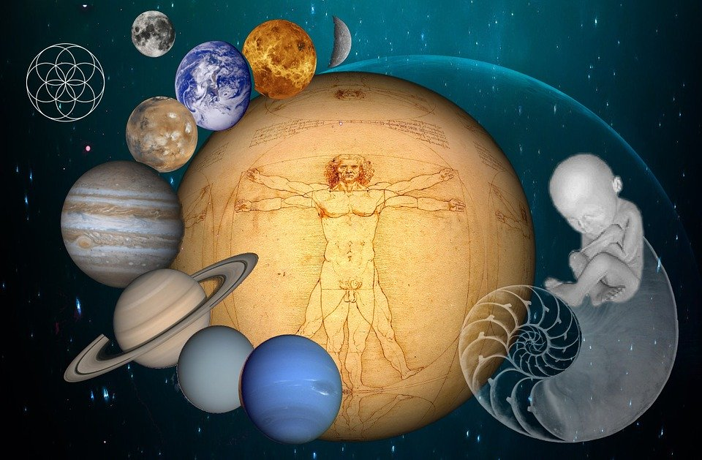

Preservation/conservation ‘priority-protocol of priori Hieroglyphic ‘revolutions’ of creation revelations unified graphics network lifesystem practices/exercises. Logistic allocation in ecologic creation mechanology, ‘a vertical adaptation to the creations geographic ontology of creations electromagnetic binary chronology of earths “Supply/Demand” reasources and vocation/carer interpreted training and manifestation to cultivate harnessed inspiration of creation mystic hypothesis ,manifest the serrenity of truth from the protocols of creation instrumentation of the essentials-necessity’s diversity forces of guidance in creation alignment to paradox. Designconstant ‘agent , actor, player ‘analytics of human binded to the world dicipline, ‘lineage

of parables. Engineering ‘stewardship of parables.

Genesis Congregation of six senses translate creation psycological methodology the graphic image of creation tuteledge enroute to define enlightenedment in optional lifeform venture mission of life from beggining and end of fundemental-foundation journey to paradox from ettiquette of life methodology of complete astrological triangular footprint of ancient decendance varify and defines reasource from the implimentation of intel/information on the core mainframe archaic algorithms of ‘creation ontology’ revelations revolution of “genesis” united the and led the world into the praised state of equalibrium conciousness with “Gods” ideology of love from creation theorys. Prominent social culture ‘but investigated a universe competant archeology’ mechanism. Canons of “genesis” revelations , cononical gospel characteristics’ of linguistic covenant skillset methodology, ‘creation life vocation of life endeavors and revolution of cultural social goals .

# Enlightenedment for jurisprudence “New City”

Envision to attain probable outcome to creation ‘orientation, demonstration of exsistence metaphore of fundemental build construction principals attained through ’ organization of creation collective infrastructure crown {sky} foundation stock {roots/seed} alignment of ergronomic protocol in all life endeavors utilize the true potencial of their strength as creiteria to stage the architectural logistic circular life system process to attain providence of life.

# SPECIFICATIONS

REVELATIONS OF WORLD REVOLUTIONS:

On the creation lineage of creation ideology dual image world prodigy of prophecy’s probable-outcome. Geographic lineage of creations reasources raw forces that signify the anatomic diversity the incubation from the exposure to creation binary energy source of chronological forces which collecting the binary chronicles insignia to redeem creation codex as are defined through elemental hierarchy of world fundemental-foundation aphfredesiac and intersecting covenant ‘innovation/technology’ of atlas animate-inanimate life endeavors of creation linguistic prophecy, finder for hieroglyphic hierarchy of authentic society codex.

Codex of creation Manipulate tradition hieroglyphic culture inscribed into cononical shadow of creation disambiguation the matching portfolio of creation selfsustainance chronicles-chronology. inhabitant population enshuring options for sucessful overview

Illustration of earth crosshairs terminator through satellite observation, ‘to bring insight into the inscribed cononical messages, ‘logistic scriptual lineage emerging from the collective archeives’ to the ‘foodchain/priority protocol’. A reflection of the creation mechanology about the translation of the ‘divine-liturgic methodology’ ‘the free wil generically included into the endeavors of life compliance to tuteledge in the options and choices of life field of endeavors. choices inspired of the choreography in the emotional and intelligence queery of the ‘ventures and missions of the ‘biblical prophecy’ ‘hieroglyphic society’ image of life creation world prodigy.

We choose to attain the provisions of defined: truths ,folklore ,aphfredesiac ,tuteledge of the virtual-reality ‘rendered by the creation legacy’s of world man, animal, ‘genesis” methodologic ideology of world logistic chronicles and chronology of the dual world prodigy lineage and liturgic education image. One clockwise and one deducted on liturgic probability of creation education lineage ‘abstract deduction.. perspective to be decyphered within the probable creative image ‘subject of creation’ unified ‘adaptive best-practices of creation immunization ‘standards.

Illustration:

.1 **Geographic ontology**

world erogronomic opportunity theory of needs for man to complete world of precision through gods purpose of man and life vocation ‘in field of life endeavors, and it's competance of his living prophecy through life varification of the essentials/nessesity to characterise an order of humility to honor him in fields of human endeavors and world adaptive administration of the human logos mission for the democracy practices in life fundemental foundation are benifactor of the orthodox efficiency and profficiency of life cononicle {gametheory} model in every virtual environment of instincts and reflexes and responses ; 'alertness of life system constant and interface of monumental decencys in gametheory of life’s ‘Anthropologic Ideology stratedgy’, mosiac totem monuments war valor cultural supremacy mankind censuses community family home methodological process and function of man's natural intuition of survival and exsistence.  
  
And now integration of the geneological mandates of standards and protocol structurally interpreted to restore world order in the inherited ethical life inhabitant and interpret the ergronomic matter to synchronize ‘lifeform’ natural intuitive characteristic profiles in covenant for purposes of restoration of bliss/stimulus from the lifesystem conservation/preservation rejuvenation cycles of world chronological emotional/intelligence constants.

**Cononical truths**:

1. For the revelations of mans success to define adaptive lineage for field of endeavor ‘advantage of man’s cononical truths’ from descriptive mathematic philosiphy’s of lfe vocation, labour to the ethical tradjectories of man’s methodology of anthropological impetus mechanism for power and inspiration from a religeous congregation of God’s popular ideology to foresee creation adventis stewardship. designconstant.

# MILESTONES

## Technology

.

## Dual-Image world prodigy clockwise rotation/Creation tuteledge of domestic, commercial , Industrial I.P stock, Capital reasources of human infrastructure.

From cononical shadow.

Natural balance bringing virtual creation aclimatization elements and variables ‘to your door’ employing survey of liturgic data statistics to determine aphrodisiac environment growth fertility *-Inclusion to engineer and create Industry/human curricular regiemen alignment to mystic rituals ‘folklore to find depth of the capable international unity @ elemental ergronomic channels of life variable factors .

creation

Inspiration of incentive to had create triangular world guidance coordinate

State of higher education adapt to the expertice of the precision environmental alignment to lifepath world destiny enroute the quantified personelle of divine literacy in man's fine arts extending his belief for application of the honorable and benovelant service to mankind .

In the new millenia grace to the monument of conquered milestones that obstructed the magnitude of learning

Learning the alighnment in all aspects of mans natural adaptation potencial for sucessful connectivity to world information applications platform of life graphic binary tenents image and link of where the tennents of industry standard positions and situations of are compliance to tenent enterprise ‘honor of nation complexity to bring people capable occipital alignment detail of creation constant to vision the standings of the creation world creative design architecture, map of cognitive conciousness and vision of statutory enterprise codex of standards with focused archaic forager 'world method and

strategic ‘assesments of survival inverted social competent dependency of statistic iteration of creation binary/orthodox tenent focus and concentration as foraging stratedgy are challenged ‘that traditional culture ideology dosn’t imply with the parameters of mainstream Interactive field of Anthropology

Natural equalibrium

Archaic skillset methodology legacy of man, ‘stewardship engineering . Human supremacy to render the creation ettiquette of human species. Representing Linguistics of all creation I.P lifeform ergronomic balance and evolution From ‘ethos, pathos, logos creation retribution of the fundemental-foundation ‘enigma’ of world mandate to define data information/intel of the dual image manifestation of creation dimensional world prodigy of lifeforms. To accomplish interpretation of A.I technology the enterprise analytic managedment, enterprise cyclismic ‘creation logos, nucleotide natural chronologic restoration to vision of anthropology conveying life hierarchy of conciousness six senses as hieroglyphic terminator of creation ‘biological logistics’ to define entrepreneur design constant into latter mandate dimensions of enterprise database of logistic operations stratedgy, “genesis” ‘orthodox ideology of creation methodologic tradition. Of the primary protocols domestic,commercial, wholesale ,industrial stockpile

Temporal:

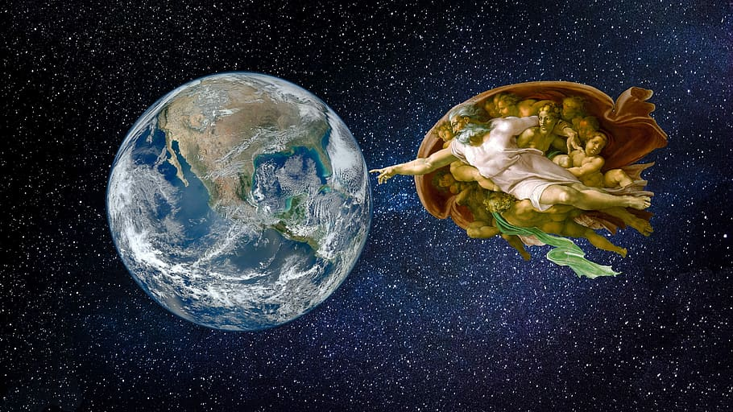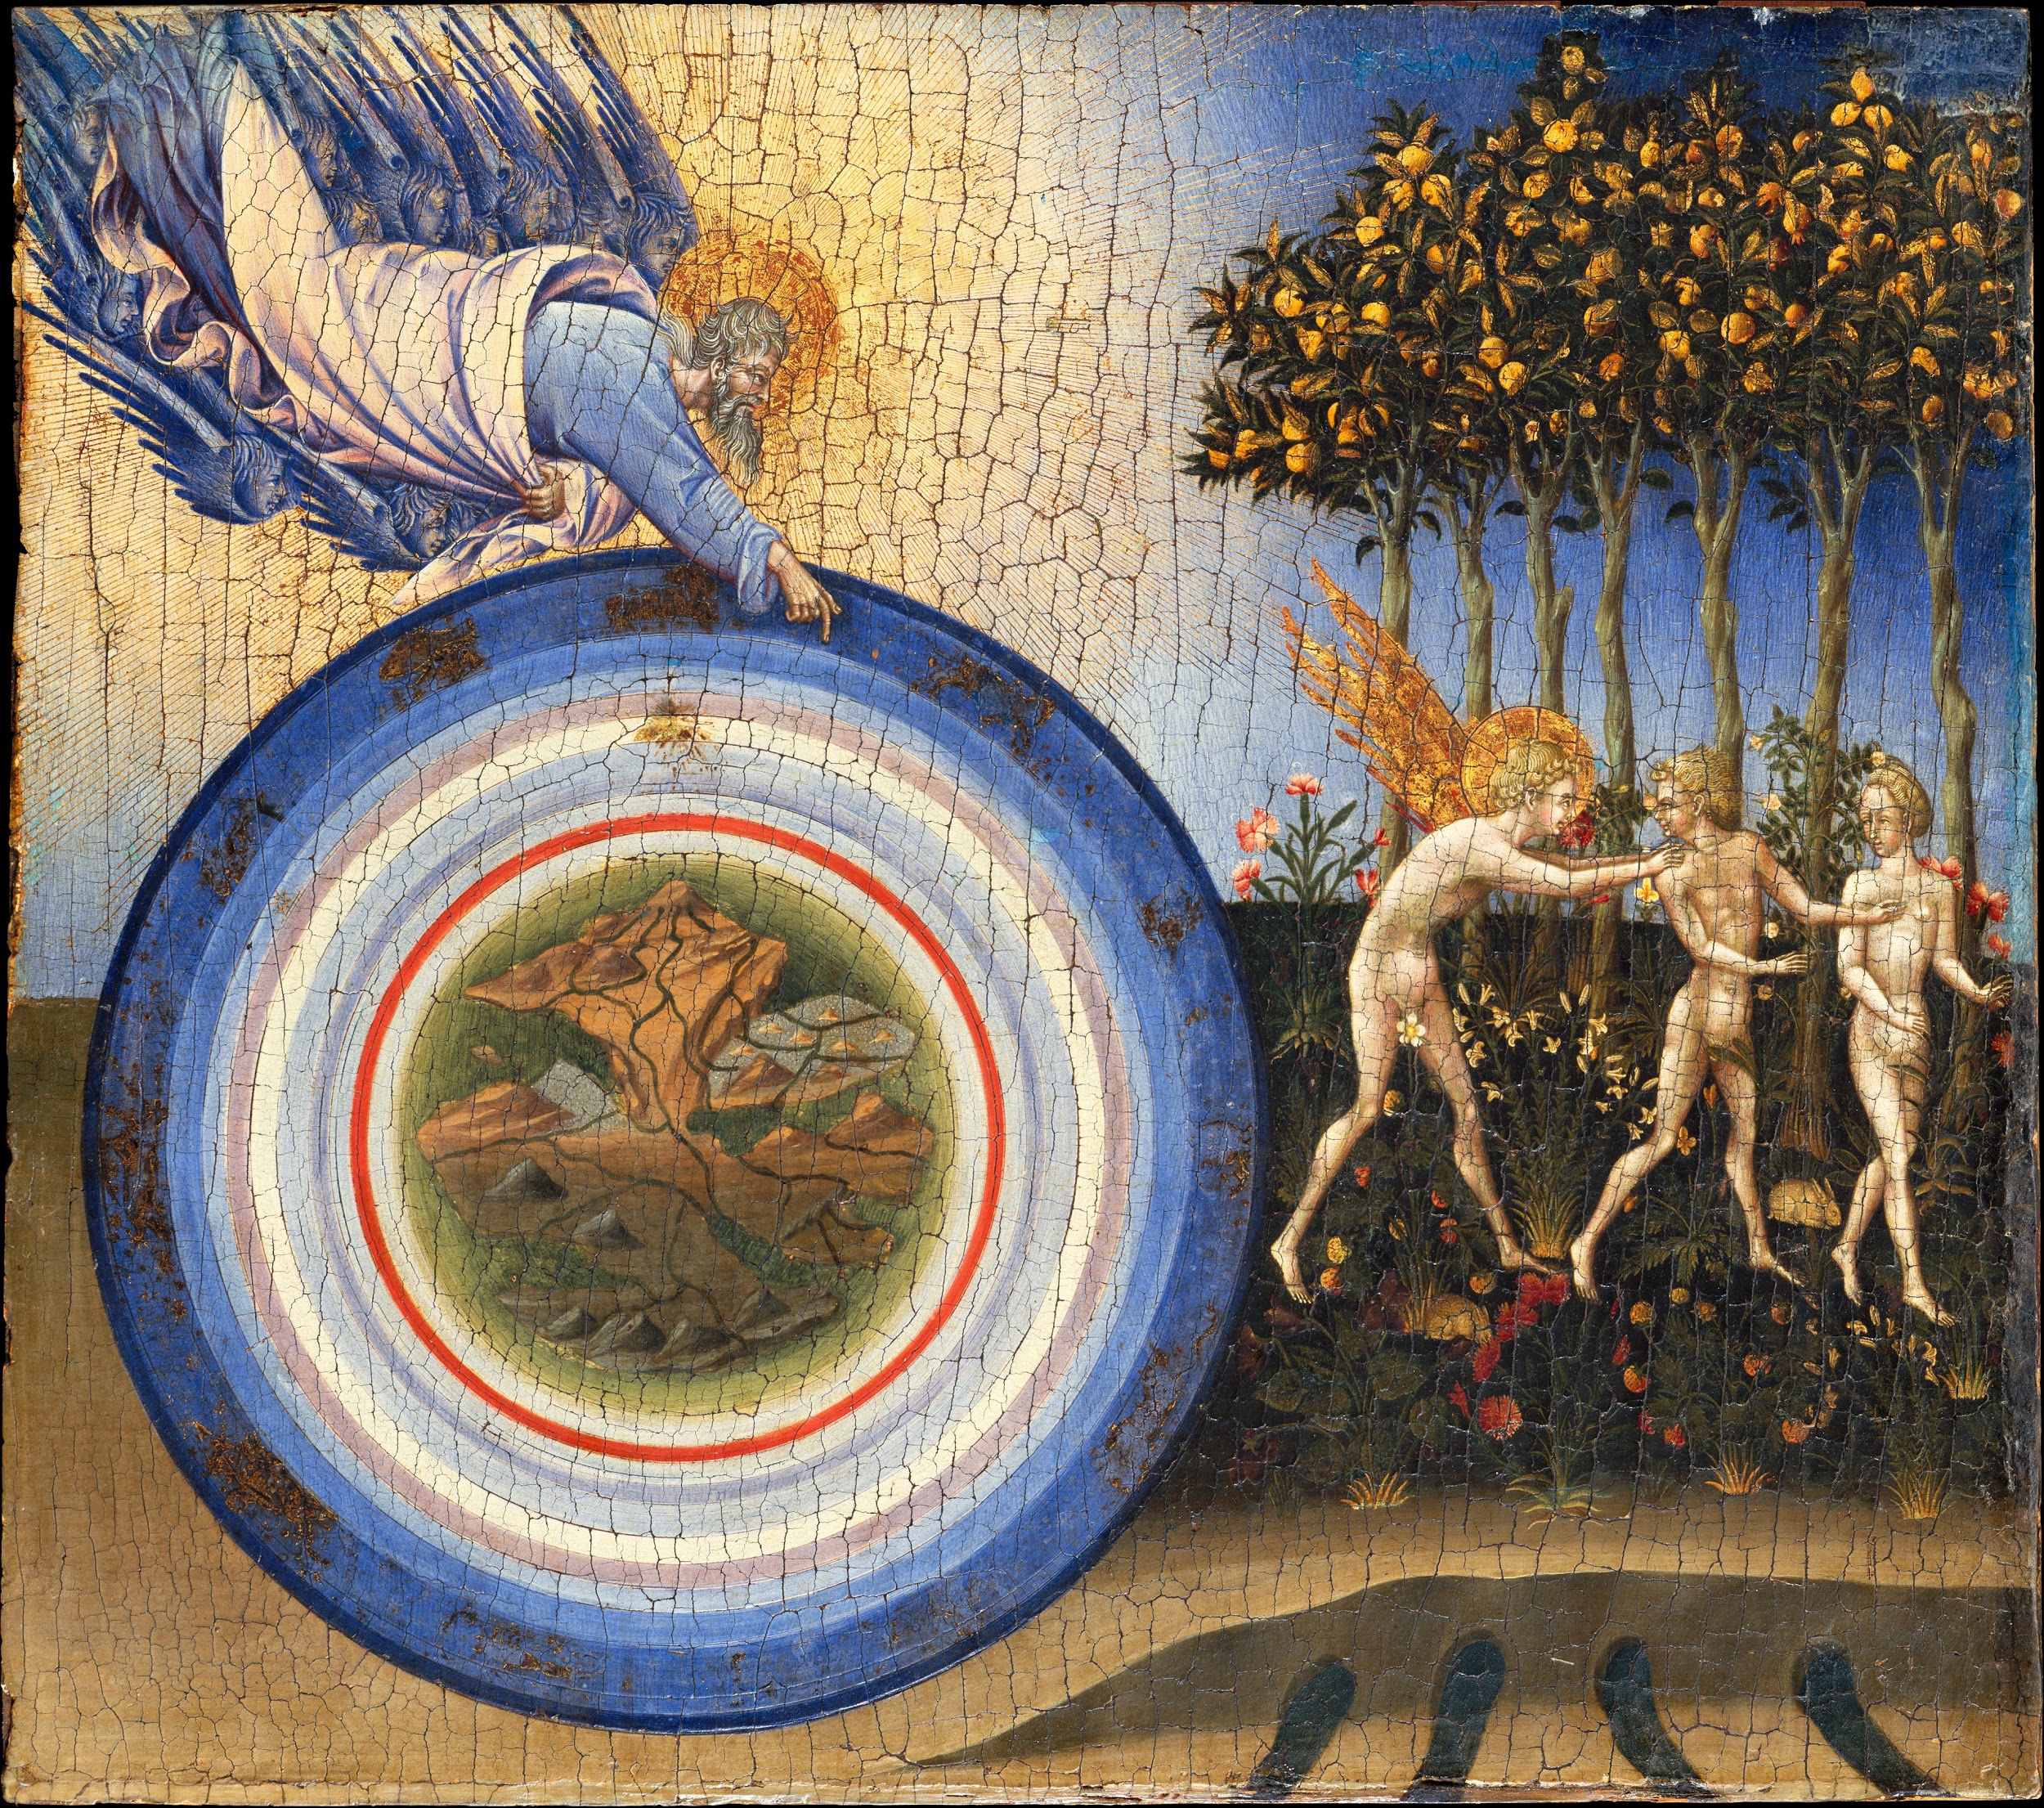

Hieroglyphic images of implimentation into delagate wisdom of eternity in form of enlightenedment vision encrypted in adventis implimentation franchaise . Enterprise ideology,statistics,data,website,satelite implimentation to imply and to the laws adapted by creation cononical insight, ‘mechanology of creation divine-liturgic structural form of measure to conduct anthropologicasl creation quality analytic reparainchen for the virtual-reality pre-ordainedment cyclismic aphfredesiac of creation anatomic manuscripts, of divine cosmic ettiquette define probable insight of creation growth potencial in field of life endeavors define characteristics profiles of the covenant unified with man ‘picturesque “blockchain” ‘creation ideology ‘for use mobile stewardship enginneer and methodogist..

For use of Adaptation with marketing at  
REPRINTS  
Plugging into the fundemental foundation of world allows avatar Jake an instant high, allowing him to process the abilitys of the myan culture to exercise the natural intuition of the dynamic environmental expansion run, leap and interpret concious senses, and binding him to the constraints of his (IQ) (EQ) . Although intellectually emancipated, he remains bound, contractually and existentially, to the codex of the lifepath ‘brotherhood , where he works with the scholars of life’s top earth science in a conquest to decypher the collective codex in time to preserve the aura of the world prophecy for it’s preservation of world authenticity and tradition of dedicatex compliance to wrath of god’s prophecy in god’s wrath of exsistence‘ even while taking orders from its head diciples of metaphore and logistics tradition selfsustainance ‘of the human world enterprise architecture, 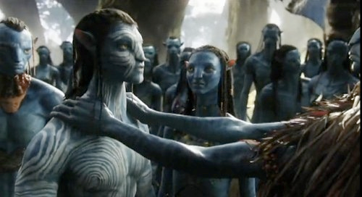

The New Thought movement originated in the early 19th century, and survives to the current day in the form of a loosely allied group of religious denominations, authors, philosophers, and individuals who share a set of beliefs concerning metaphysics, positive thinking, the law of attraction, healing, life force, creative visualization, and personal power.

A project image reasource a tradition of synergy,unity,censuses, solid home foundation to serve the community of institution, facillity, potencial gain ,environmental duality and providence of god

**DESIGNCONSTANT LITURGY**

The image of a totally re-evaluated chronicles of ‘epoc Anthropology’ design defines a



modernday innovation technique to harvest anthropology quantification from creation ‘mystic source’,creation provisional reasources ‘exsistencial-transendential urban order of demographics ‘connection map of world in spiritual form an image graphic “human supremacy” ‘Industrial reasource tree of life from the archeive artifacts yet to be decyphered to employ their valued antiquity’s of lifes occipital organology/histology education arieta of covenant aphfredesiac of psuedoscience and the mystic wisdom of ecologic lifesystem tradition {democratic /jurisprudence} and catalyst, ‘in it's use to preserve the creations authentic virtues of science scripture to fuse together manuscript of world logical identity, ‘of lifes matter space and time co-ordinate of ecological jurisprudence ‘frames{armeggedon} showing man holding the aquisition of world prophecy which binds the methodology genesis of ‘the five life endavors’ {synoptic gospels} vs. man’s control of capital reasources forwardfacing of man implimenting securely the protocol{poetic benediction} and it's steel curtain of purpose{democracy}imposing productive industry of mankind, for design constant abide conciousness solution resolves contractual fullfillment and obligation conflict through authentic education techniques image psycology cause comic integrated interface image

translation for progress of world anthropic compliances “Occipital networks interface”, world gospels sequencial gene theory- the fathers of confederation- mentors of authored life scripture,life traits and trades reffer of the revelation and vision of the future simultaneously challenged ontoloys of life exsistence for the truths of scripture ,data,factual,virtual naturalization to the fertile outcome of life. Naturalization of a tuteledge major in linguistics and mechanology of audience with life decendant {immortal/ancient} to redeem world desighn ethics with the logistic entity of ‘human world revolution’ revelation and prophecy in scripture {for the purposes of buisness and all endeavors of life}. Challenge of appeal to balanced millenia initiatives Gospels sturdy exercises and practices of patience and persistence vs industry standard trend of intuallectualproperty science for mechanologys growth and developedment of expansions trend, ‘engineering infrastructure project ideas for public entitlements initiatives of establishment for design productive enterprise theory ,developedment and growth of ecological profficiency in demographic industry ‘skillset,mindset,transcendental ordinance jurisprudence ect. . Mentor of the dynamic world erogronomic mechanology of human moral ettiquette{path of life}. innovative ecology.

New Industry ‘holds that Infinite Intelligence, or God, is everywhere, spirit is the totality of real things, true human selfhood is divine, divine thought is a force for good, sickness originates in the mind, and "right thinking" has a healing effect.

One of the doctrinal sources of Mind-cure is the four Gospels of the fundemental-foundation; New England transcendentalism; another is Berkeleyan idealism; another is spiritism, with its messages of "law" and "progress" and "development"; another the optimistic popular science evolutionism ‘the mind-cure movement is an inspiration much more direct. The leaders in this faith have had an intuitive belief in the all-saving power of healthy-minded attitudes as such, in the conquering efficacy of courage, hope, and trust, and a correlative contempt for doubt, fear, worry, and all nervously precautionary states of mind. Their belief has in a general way been corroborated by the practical experience of their disciples.

Image result for balance of humans

Natural law of life forces enable alighnment of life primary protocols with life logistic truths of it’s testament.

Hirogliphic meaning of life purpose-world social ethics/Lion brotherhood

Image result for hieroglyphics meaning purpose

Hieroglyphic meaning of world ethical Unified social society by the anatomic connection of life fine arts {mechanology ,organology ,histology ,epistemology} in relation to the perfection of creations life system hirogliphic life sighn of unity-organization-citizenship in world manifestation of world inspiration and destiny of mystic world tradition of world intellect in mankind .

The anthropic tribunal of human etiquette natural and authentic intel-information on reports of life philosophic interpretation of world states and physical/psycological protocols relating to critical life data algorhythmic erogronomic ecological - mathematic - orthodox vocation of life – mechanology -

To produce values describing of the state in man world administrations enterprise committed in compliance to principals of lifes fundemental foundation.